# Open Transit Indicators

End Users’ Guide

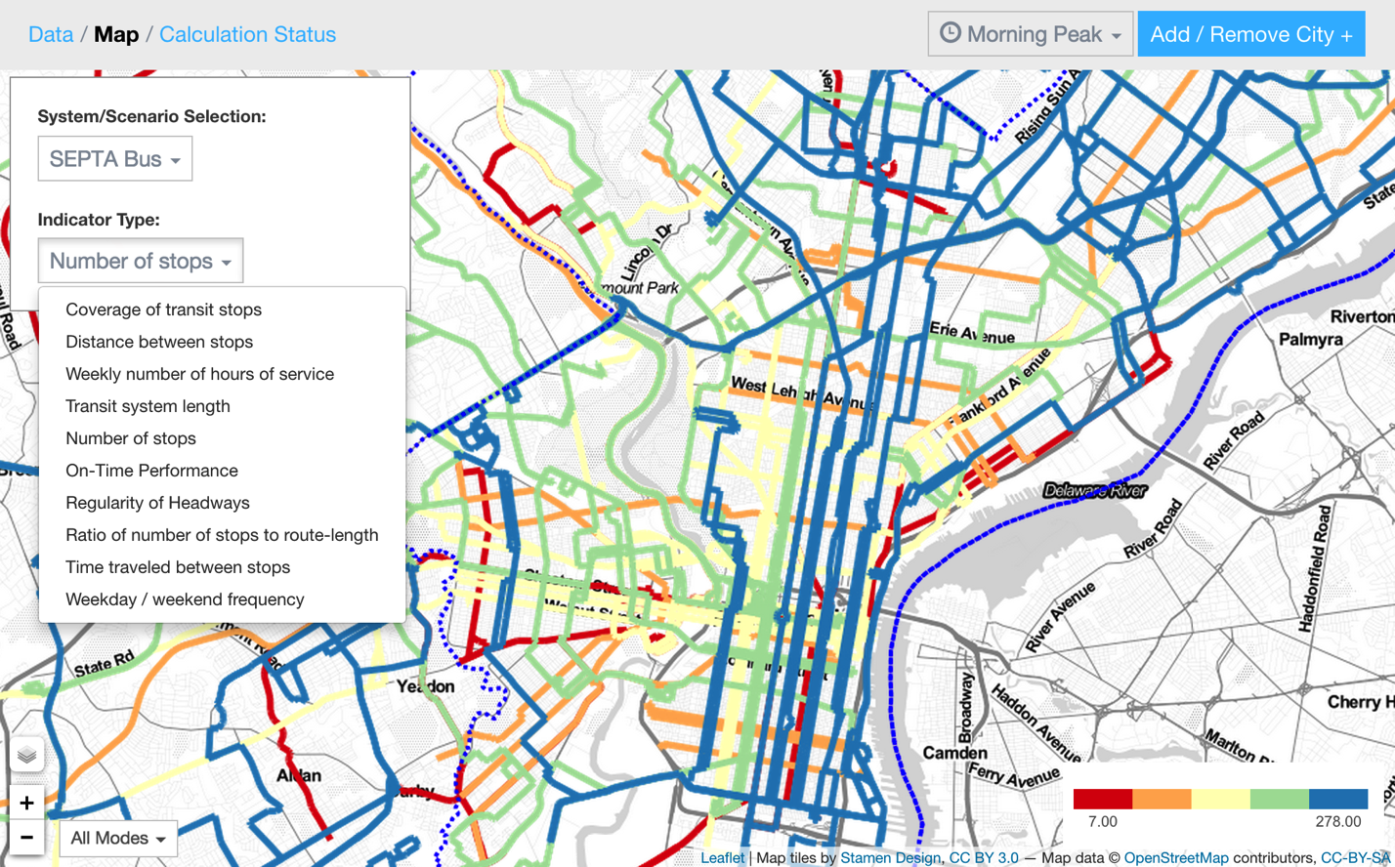

|  |  |
| --- | --- |
| Prepared for:  http://www.worldbank.org/content/dam/Worldbank/WBG_Horizontal-RGB-web_300x59.jpg  1818 H Street, NW  Washington, DC 20433 | By:  **Description: Description: azavea_RGB_72dpi_white_sm**  340 N 12th St, Suite 402  Philadelphia, PA 19107  (215) 925-2600  <http://www.azavea.com> |

# Table of Contents

[Open Transit Indicators 1](#_Toc407386659)

[Table of Contents 2](#_Toc407386660)

[Introduction 3](#_Toc407386661)

[Browser Requirements 3](#_Toc407386662)

[Feature Overview 3](#_Toc407386663)

[GTFS and GIS Data Integration 3](#_Toc407386664)

[Observed Performance Data 4](#_Toc407386665)

[Performance and Accessibility Indicators 4](#_Toc407386666)

[Scenario Design 5](#_Toc407386667)

[System Configuration 5](#_Toc407386668)

[GTFS Upload and Settings 6](#_Toc407386669)

[GIS Data Upload and Settings 7](#_Toc407386670)

[Observed Data Upload 8](#_Toc407386671)

[Additional Configurations 9](#_Toc407386672)

[Transit Map 10](#_Toc407386673)

[Indicator Calculations 11](#_Toc407386674)

[Indicator Results 13](#_Toc407386675)

[Scenario Building 15](#_Toc407386676)

[Creating a Scenario 15](#_Toc407386677)

[Creating Routes 16](#_Toc407386678)

[Finishing and Calculating Indicator Results 19](#_Toc407386679)

[Multi-User Support 20](#_Toc407386680)

[Acknowledgements 21](#_Toc407386681)

Open Transit Indicators

End Users’ Guide

# Introduction

This manual is intended for the of the Open Transit Indicators (OTI) application. Administrators of the application may refer to the System Administrators’ Manual. This manual is written to serve as both a tutorial and a reference. By following the steps outlined below, a user new to OTI can learn to configure and use the system.

# Browser Requirements

OTI runs in modern browsers. The application makes extensive use of asynchronous requests and JavaScript, and so JavaScript must be enabled in the browser. Supported browsers (December 2014):

* Google Chrome 36+
* Mozilla Firefox 31+
* Microsoft Internet Explorer 10-11
* Apple Safari 7-8

The application may work in certain tablet browsers, but it was designed and intended for full desktop browsers.

# Feature Overview

OTI is a web application designed to let public transit system administrators understand performance and accessibility metrics based on system GTFS data and other geographic data. It also provides a platform to sketch modifications to the transit system, calculate the same metrics on the scenario, and view the results side-by-side.

## GTFS and GIS Data Integration

**Required data:** GTFS

**Optional data:** GIS boundaries, GIS demographics, TransitTime data

OTI validates and maps GTFS data and GIS data. When GTFS data is initially imported, the application runs a validator to check for common GTFS errors before storing the data in an internal database. The application then identifies where in the world the transit system is located, and chooses the best local coordinate system in which to store the data. Because the system performs spatial calculations, it is important to use a coordinate system that accurately represents distance and area. OTI chooses a Universal Transverse Mercator (UTM) based on the latitude and longitude of the GTFS data.

OTI can also calculate metrics using GIS data. It uses two boundary files (city and metropolitan area boundaries) and demographic data to support advanced accessibility and performance metrics. The boundary files only need a single polygon per file, with no required attribute data. The demographic data should be provided at the most granular resolution available, and requires three attributes:

* Population metric 1: the primary population field – may be total population, working-age population
* Population metric 2: the secondary (comparison) population field – subset of the population such as low-income, elderly, etc.
* Destination metric: important destination locations, such as jobs – could also be used for tourism attractions, retail locations, etc.

Including GIS data is optional. If it is not present, the system will continue calculating the other metrics with available data.

## Observed Performance Data

OTI accepts data output from the open source TransitTime software to calculate planned versus actual system performance based on vehicle GPS data. More information about this software can be found at:

<https://github.com/WorldBank-Transport/Transitime>

Including this data is optional. If it is not present, the system will continue calculating the other metrics with available data.

## Performance and Accessibility Indicators

OTI calculates a number of performance and accessibility metrics, referred to as “indicators”, after the system is fully configured. The system calculates the following indicators:

* Affordability: The ratio of one month of round-trip commuting to one month of poverty-line income. If a = average one-way fare and i = yearly poverty-line income, affordability = (a\*42) / (i/12).
* Average Service Frequency: How often a vehicle will arrive at a particular stop for a particular route.
* System Stop Coverage: The percent of the urban area that is within the configured distance from stop locations.
* Distance Between Stops: The average distance between stops, per route and mode.
* Dwell Time Variance: The average variance in minutes of dwell time (requires observed stop times).
* Weekly Number of Hours of Service: The number of hours per week that the system provides service.
* Job Accessibility: The number of jobs vs. the number of individuals who can reach a job location (destination metric) within the configured commute time.
* Length: The sum of the total length of each route in the transit system. This indicator does not account for road or rail shared by multiple routes.
* System Road Coverage: The ratio of transit system length to the length of the road network. This indicator accounts for multiple routes sharing the same roadway.
* Network Density: An index value: the total length of the transit network in comparison to the total area of the urban area.
* Number of Modes: Total number of different transit modes in the system.
* Number of Routes: Total number of routes in the system.
* Number of Stops: Total number of stops in the system. Stops shared by multiple routes are counted only once.
* On Time Performance Variance: The average variance in minutes of arrival time (requires observed stop times).
* Ratio of Suburban Lines: The ratio of lines operating outside the urban area to the lines operating only within the urban area (based on urban boundary data provided under the Settings tab).
* Regularity of Headways: The average variance in minutes of headways (requires observed stop times, which come from the uploaded GTFS data).
* Population-weighted Service Frequency: Average service frequency adjusted by the number of individuals within the configured distance from stops. More frequent service in areas of high population would result in a higher metric.
* Population-weighted Service Frequency (2): Population-adjusted service frequency for the secondary population attribute..
* Stop Density: The number of stops per kilometer of a route.
* System Accessibility: The percentage of the population metric 1 that is within the configured distance from stops.
* System Accessibility (2): The percentage of the population metric 2 that is within the configured distance from stops.
* Time Traveled Between Stops: Average amount of time traveled between subsequent stops along a route trip.

## Scenario Design

OTI provides an interface to sketch potential changes to the transit system, calculates the indicators based on the changes, and allows side-by-side comparison of the results. Scenarios can be shared among colleagues with access to the OTI server.

# System Configuration

Upon initially logging into the system, an administrator can configure the application with the transit system GTFS data, GIS data, and the results of the TransitTime analysis. Setting time periods for the indicator calculation, valid dates for GTFS, and other configuration options are completed at this time.

## GTFS Upload and Settings

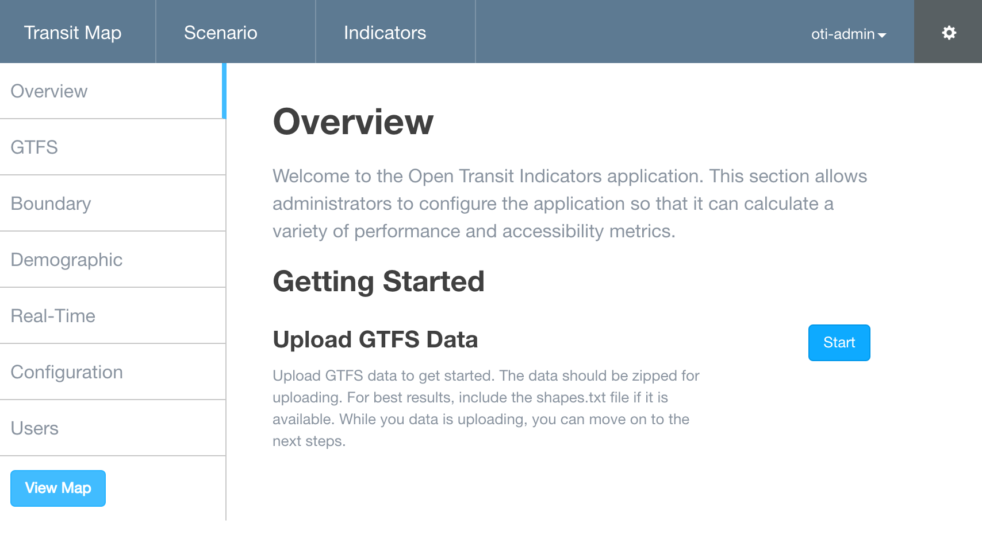

Click the “settings” gear icon in the top right corner to access the settings menu wizard.

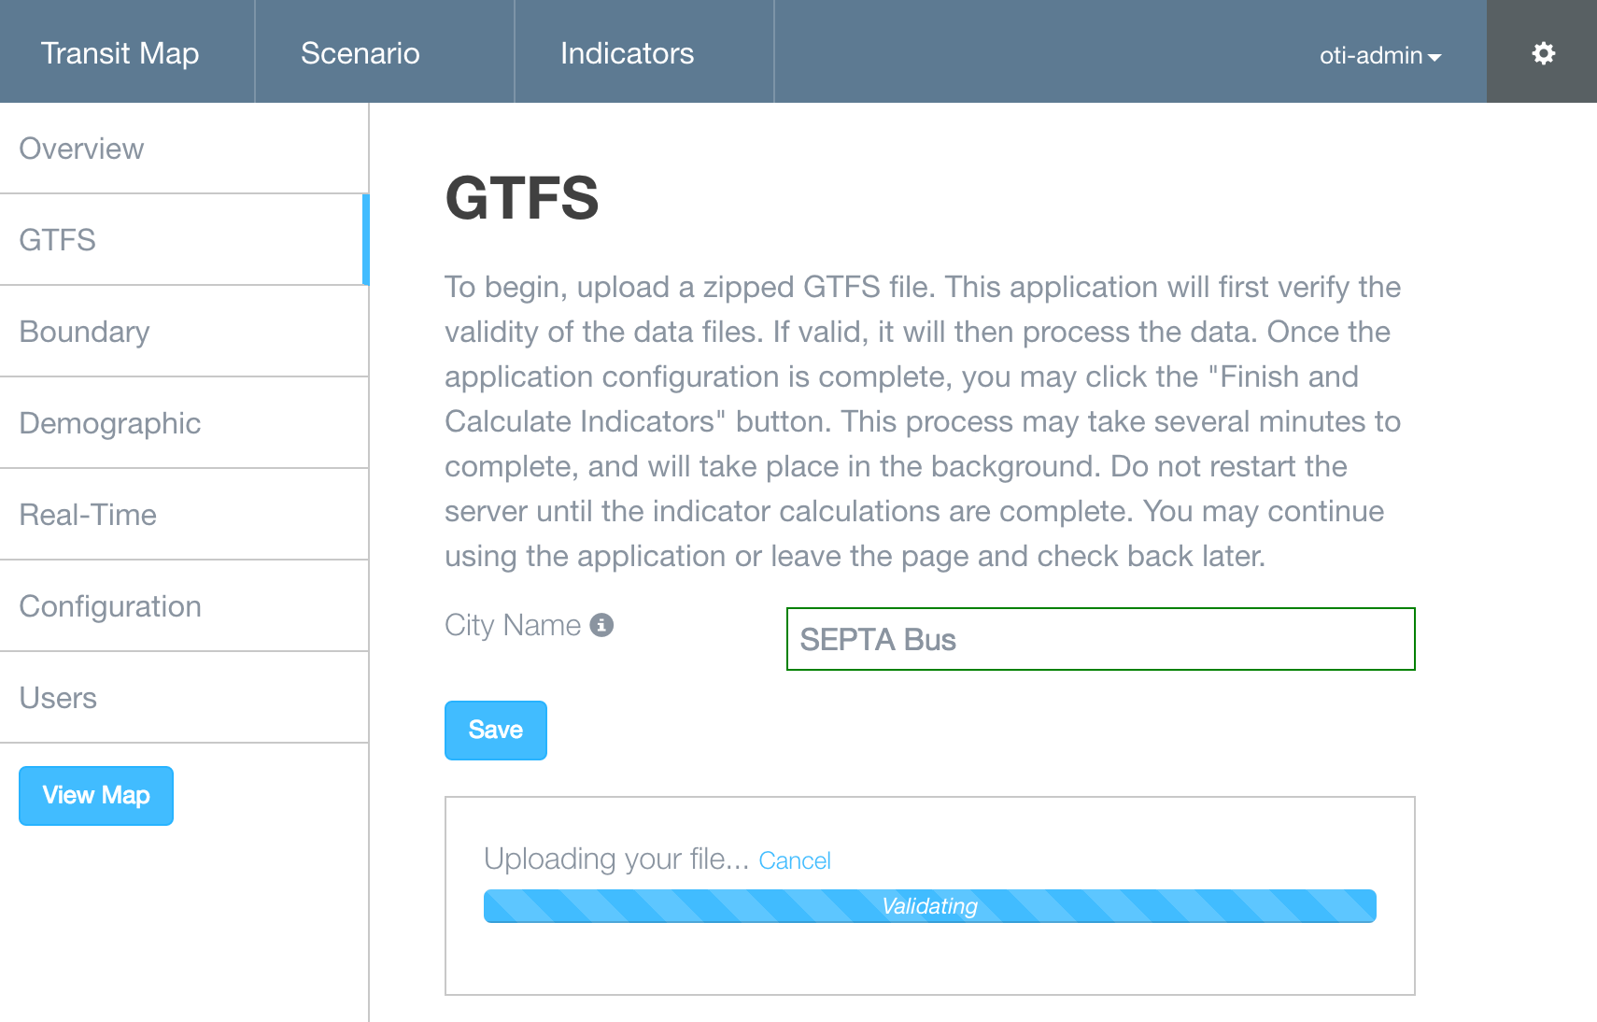

Drag-and-drop or select GTFS data to upload. Uploading and validating GTFS data may take from less than one minute, to over ten minutes, depending on the size of the system. Name and save the “City Name”.

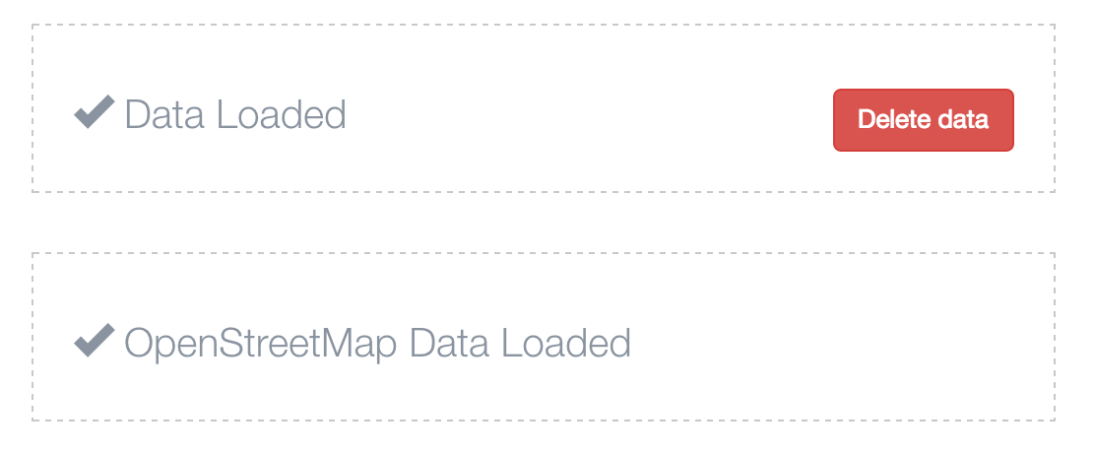

When the GTFS data is loaded, the system will automatically ingest OpenStreetMap data, using the minimum and maximum coordinates of the GTFS data.

## GIS Data Upload and Settings

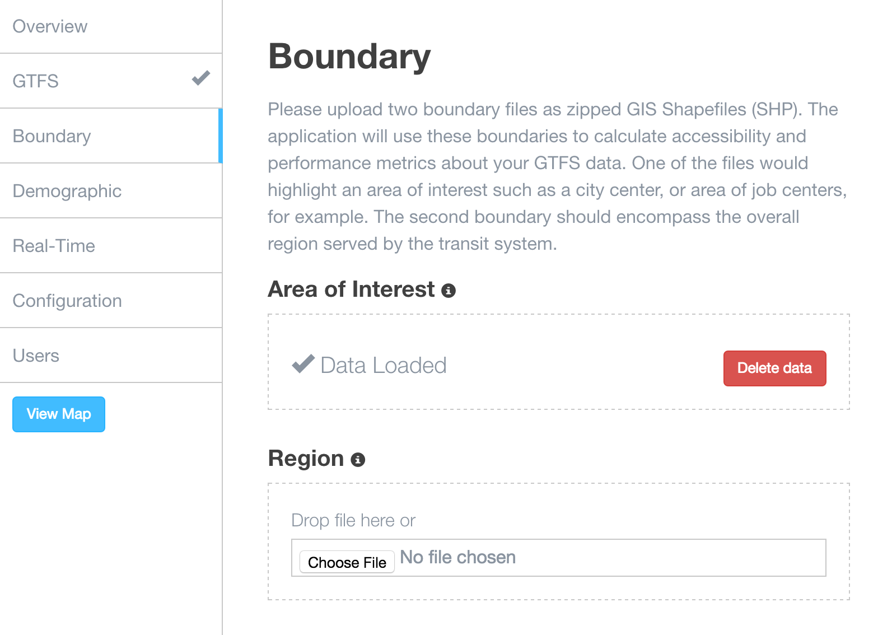

Upload boundary and demographic data, if available, using a similar interface to the GTFS data.

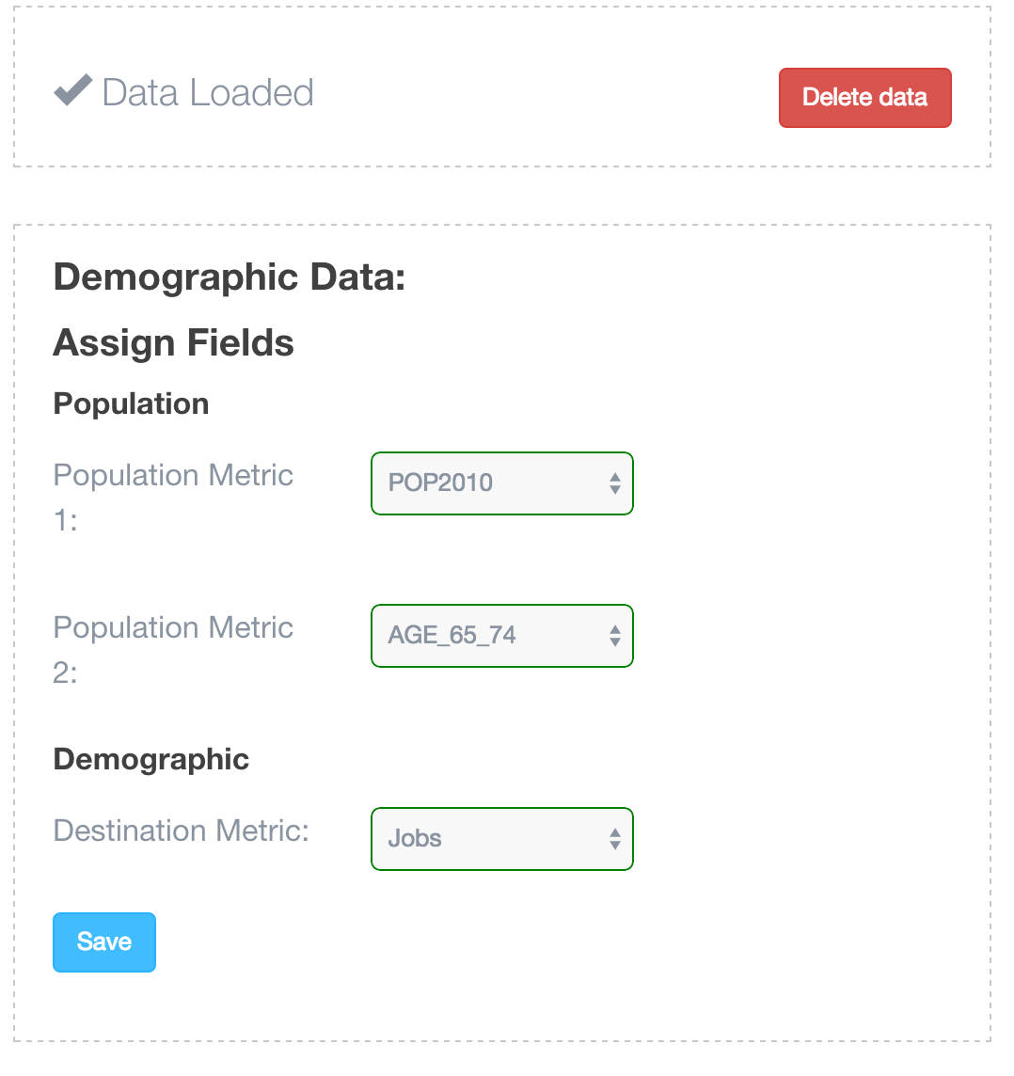

Once the Demographic data is uploaded, the software will present a few additional configuration options: two population metrics and a destination metric. The first two metrics are calculated specifically in indicators for accessibility, and the destination metric is the data driving the jobs accessibility indicator.

* Population Metric 1: Overall population
* Population Metric 2: Subset of overall population that is of interest – could be low-income people, the elderly, etc.
* Destination Metric: Used to evaluate how well the transit system provides access to specific “destinations”, such as jobs, schools, hospitals, etc.

Through this flexibility in adjusting the population and destination metrics, a wide range of studies can be undertaken, such as evaluating the following accessibility scenarios:

* Low-income people to transit services
* Low-income people to jobs via transit
* Low-income school-age children to schools via transit
* Elderly people to hospitals and clinics via transit
* Hotel guests to tourism destinations via transit

## Observed Data Upload

If available, upload the TransitTime data. The TransitTime software outputs a file entitled stop\_times.txt\_new. This is the file that should be uploaded to OTI. Some very large systems may result in a large stop\_times.txt\_new file, which may take up to 15 minutes to process.

## Additional Configurations

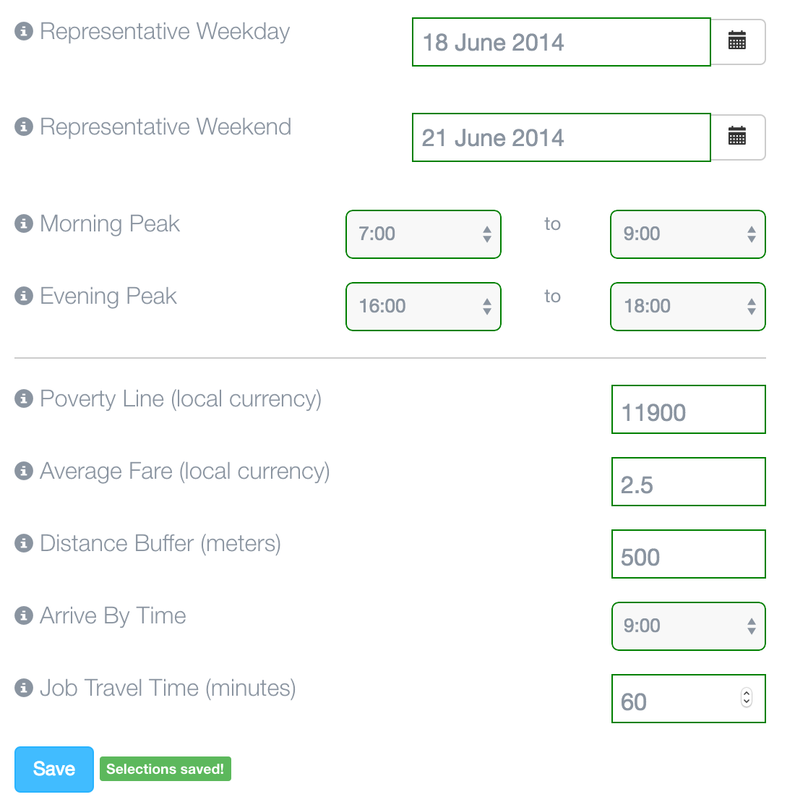

Complete the additional configurations. All fields are required.

## Transit Map

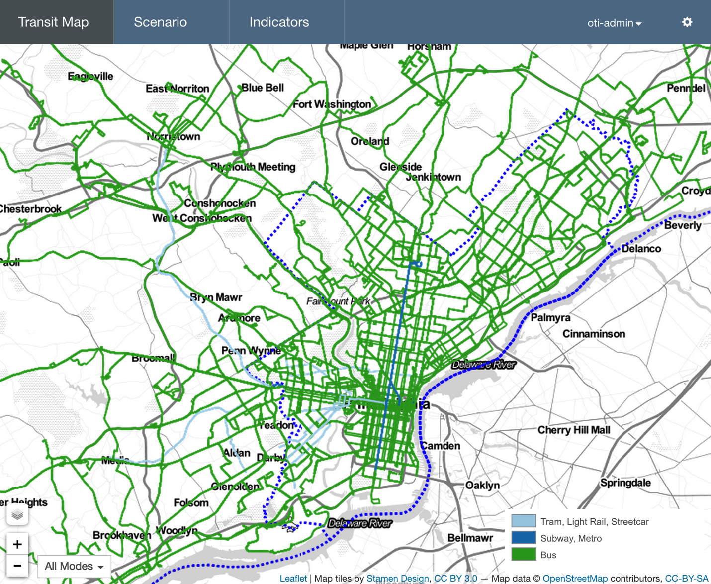

At any point after the GTFS data is uploaded, navigating to the “Transit Map” link in the main navigation bar will present the transit system drawn on a map. Layers can be turned on and off using the layers button at the bottom left side of the map. Clicking on stops will display the name of the stop, as well as routes that stop at that location. Using the modes filter will display one or all of the modes of transit included in the system.

## Indicator Calculations

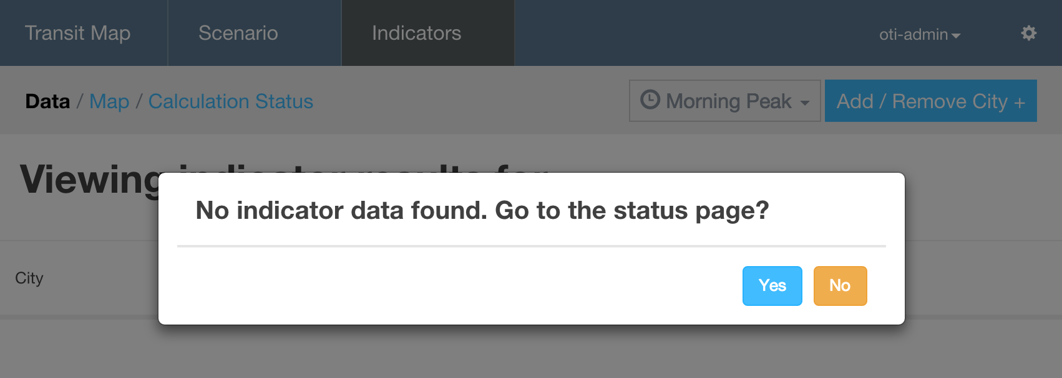

After configuring the settings of the application, the first time navigating to the Indicators page will result in an alert that indicators have not been calculated yet. Click yes to go to the Calculation Status page.

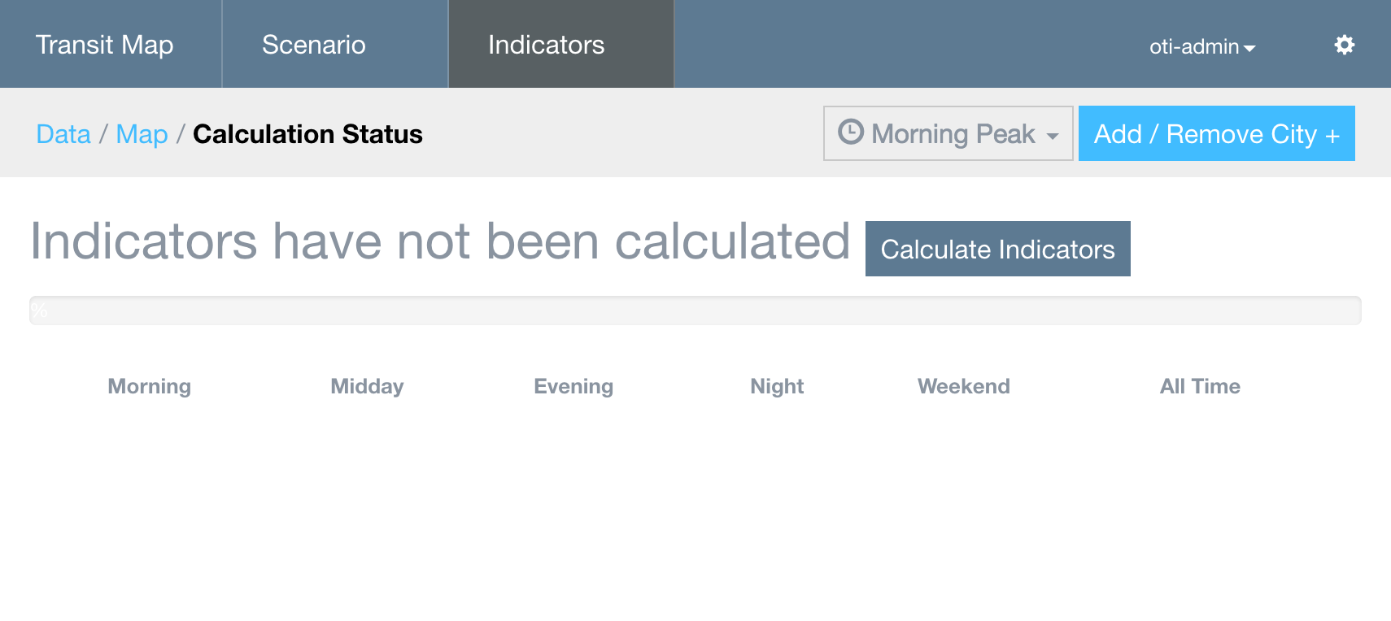

Click the Calculate Indicators button to begin the calculation. Indicator calculation may take between 5 and 30 minutes, depending on the size of the transit system and machine resources.

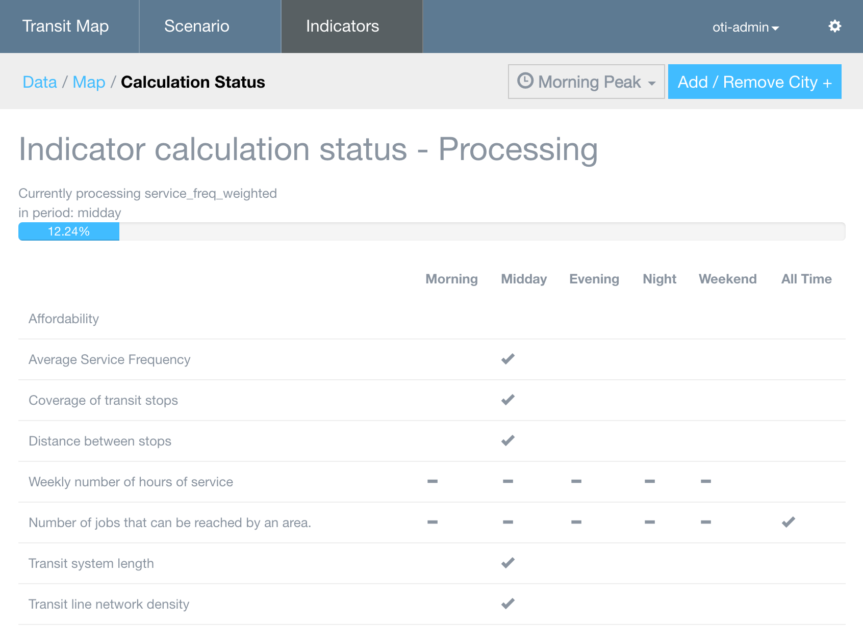

OTI will display the status of the indicator calculations for the duration of the process until the calculation has completed. Indicators can be recalculated at any time if additional data or different configurations are available.



## Indicator Results

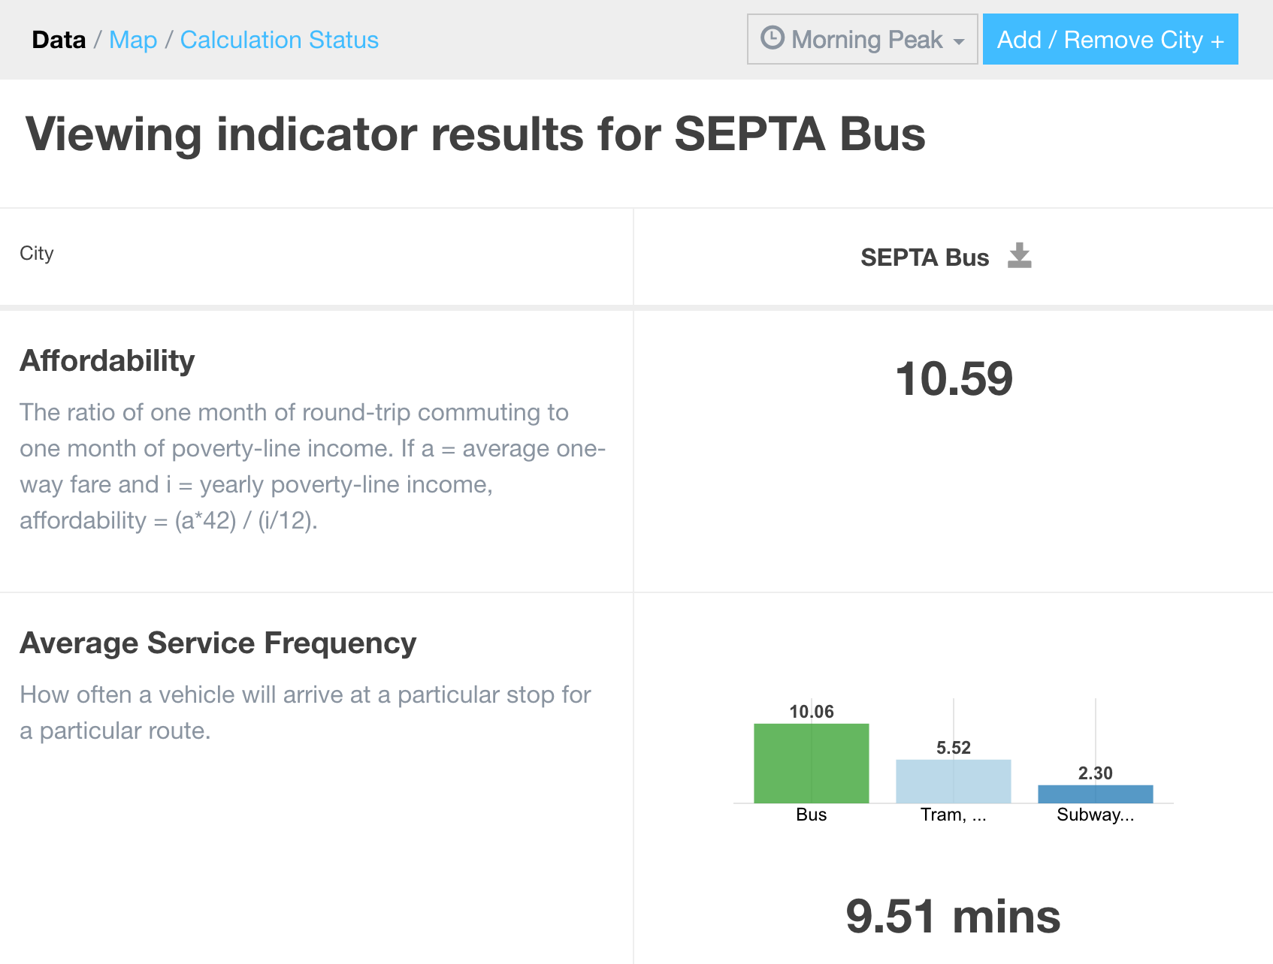

The results of the indicator calculations can be viewed on the Indicators Data page. Results can be downloaded in CSV format for further analysis and detail by clicking the download button next to the system name:





Indicator results may also be viewed on a map in the Indicators Map page. The results of certain indicators can be chosen from the dropdown on the left side of the map. Additionally, the system can be filtered by mode.

# Scenario Building

OTI provides an interface for designing potential changes to the transit system. The scenario tools enable adding modes, routes, stops, and lines, as well as scheduling. Scenarios are locked to particular time periods (morning peak, weekend, etc.). To view scenarios side-by-side, they must be designed in the same time period.

## Creating a Scenario

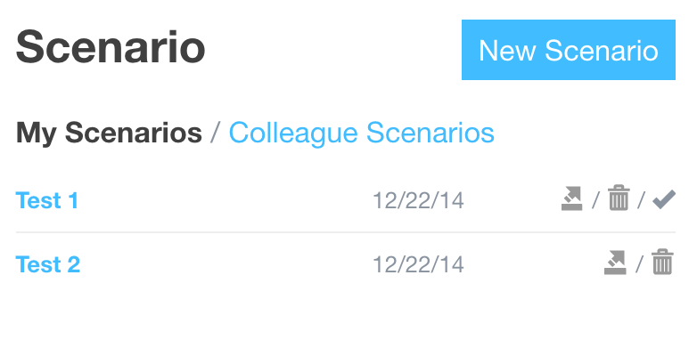

To work with scenarios, either click the New Scenario button or the name of an existing scenario to load it.

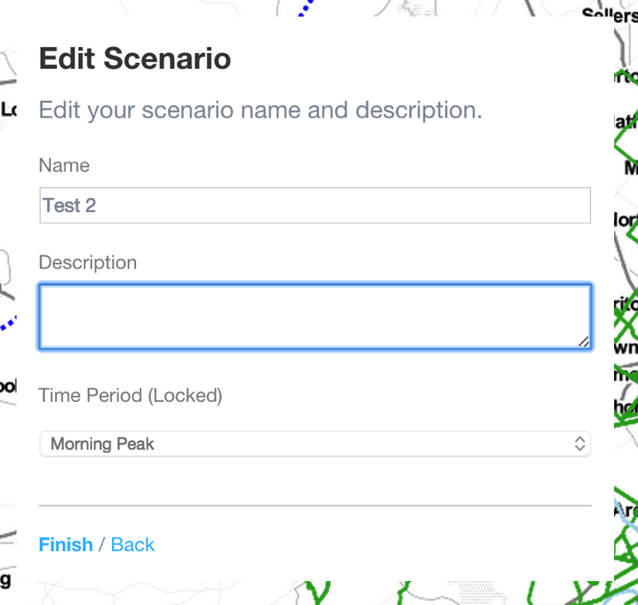

After clicking New Scenario, a dialog appears for the user to name and describe the scenario, and to choose the time period in which the scenario is set.

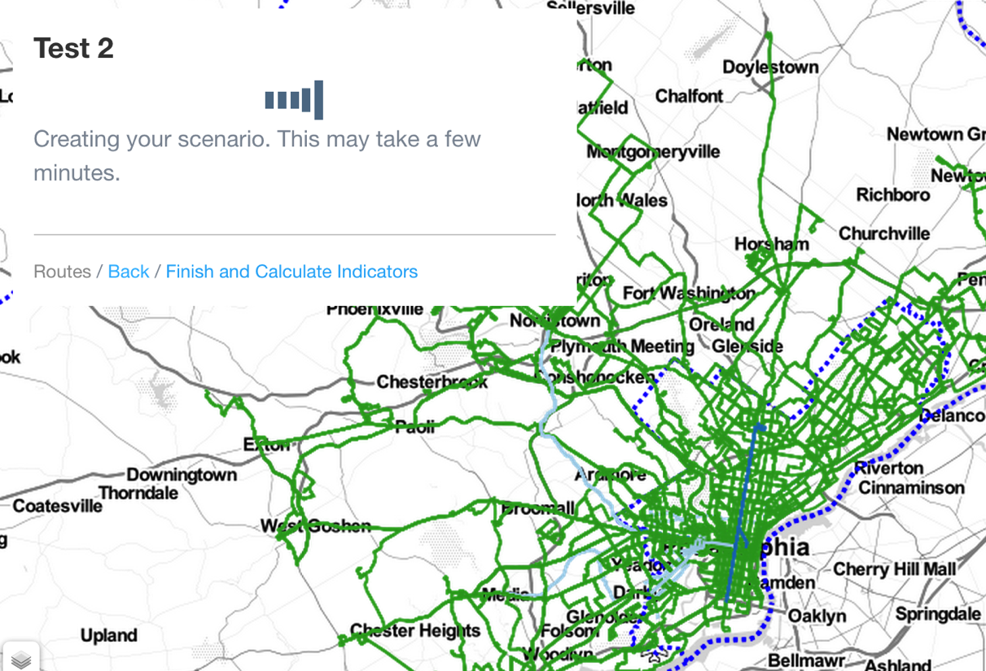

Upon naming and describing the scenario, the software may take a few minutes to set up a unique database and prepare for scenario editing. After the scenario is successfully created, click the Routes link to begin.

## Creating Routes

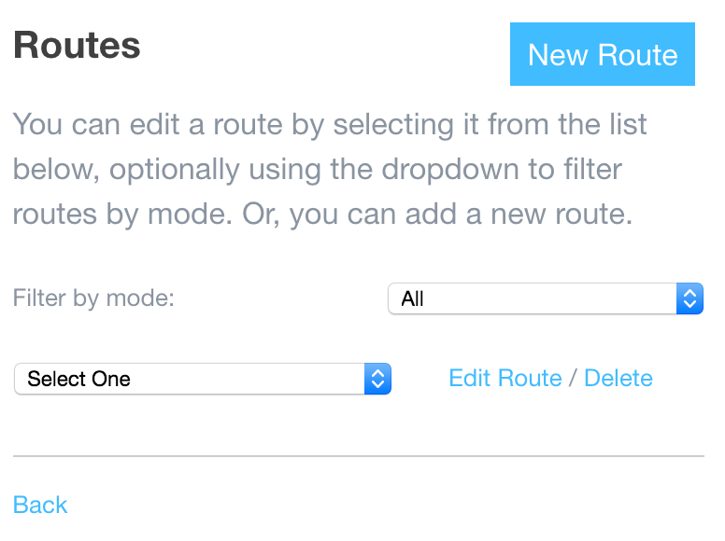

The next step is defining the route. Either choose an existing route, or create a new one.

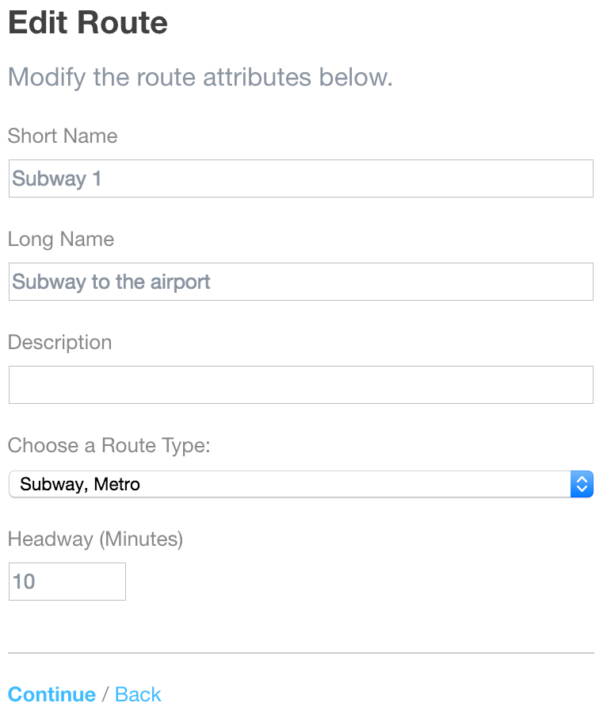

Edit the route name and description, choose a route type or mode, and set the headway for the scenario route. The headway will define the frequency with which vehicles will be calculated to arrive at a particular stop. When complete, click Continue.

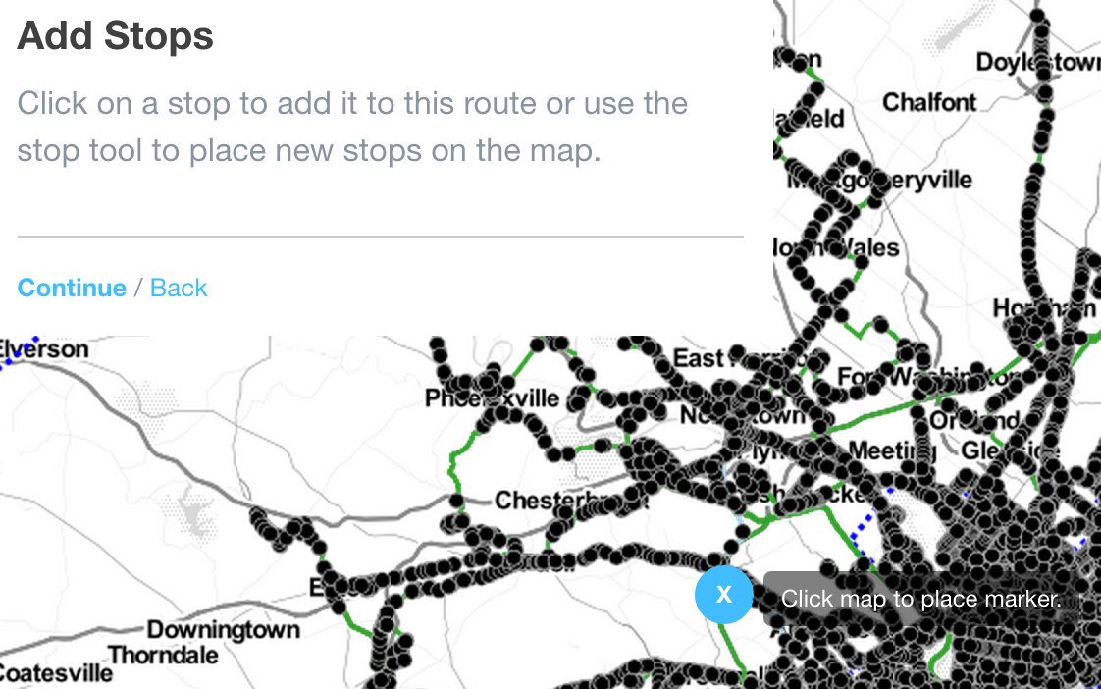

Add stops to the route by using the marker tool at the upper right-hand corner of the map…

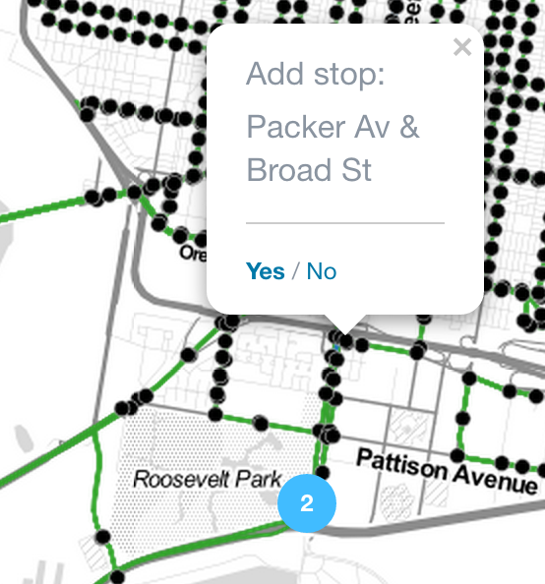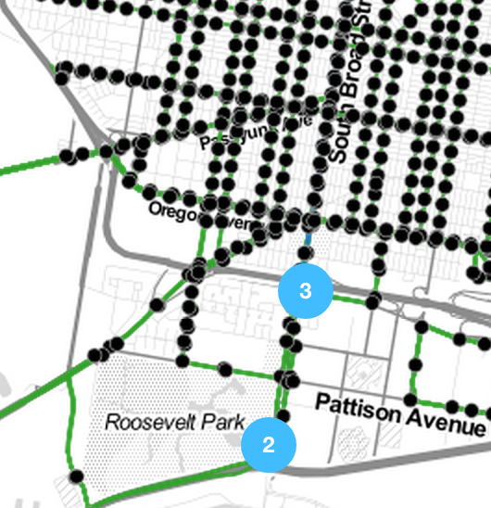

Or by clicking an existing stop and choosing Yes. After placing stops, the sequence can be adjusted by clicking on the stop icon and changing the sequence in the info window. After all stops have been added and sequenced, click Continue.

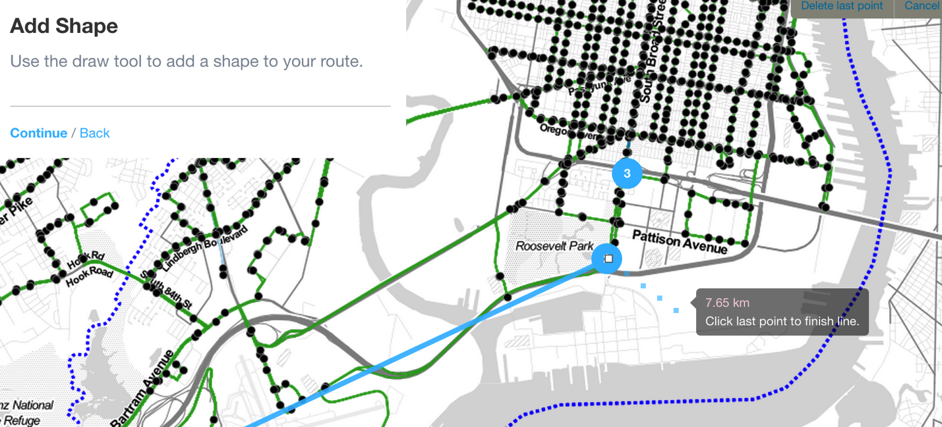

Shapes may be added to connect the stops. Use the draw tool in the upper right-hand corner of the map, or simply click on each stop in order to let the software connect them. When finished adding the shape, click Continue.

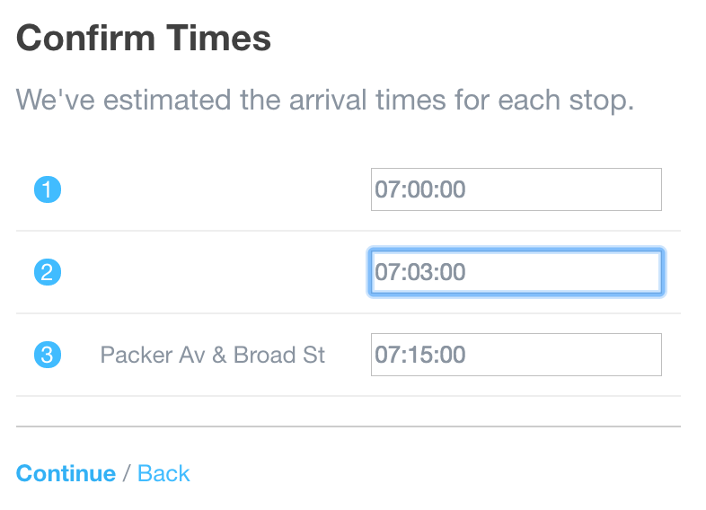

The software estimates the travel time for each stop. Confirm the stop times, or modify them, to complete the route process. When finished adding routes, click the Scenario link.

## Finishing and Calculating Indicator Results

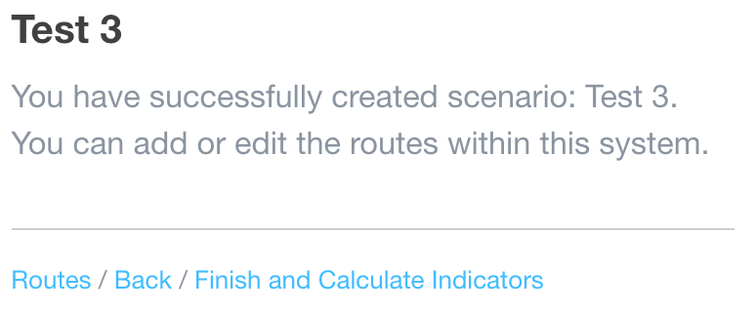

The scenario is complete. Click Finish and Calculate Indicators to run the indicator process on the new scenario. When the process is complete, the results are viewable side-by-side on the Indicators Data page. The results are also viewable on the map.

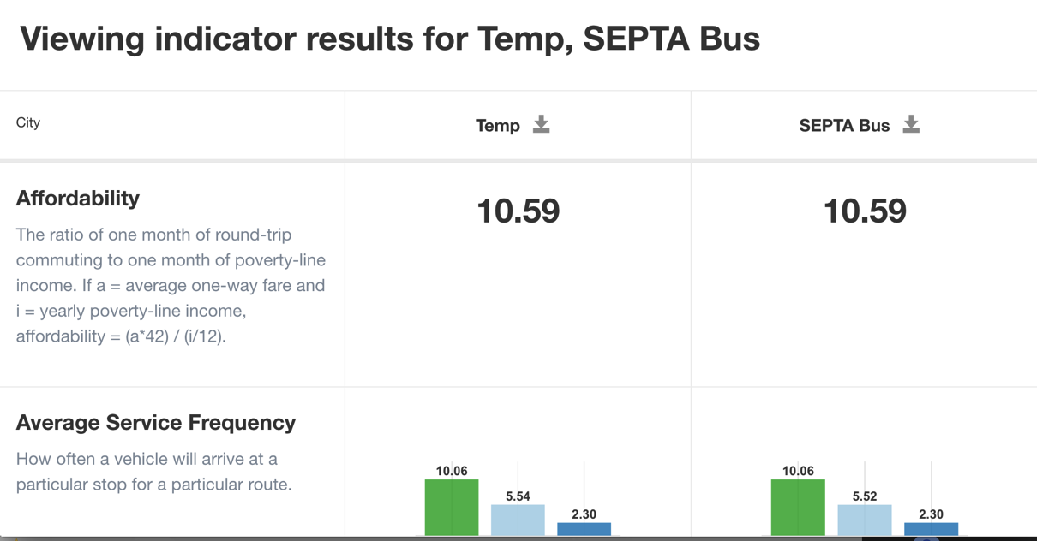

## Multi-User Support

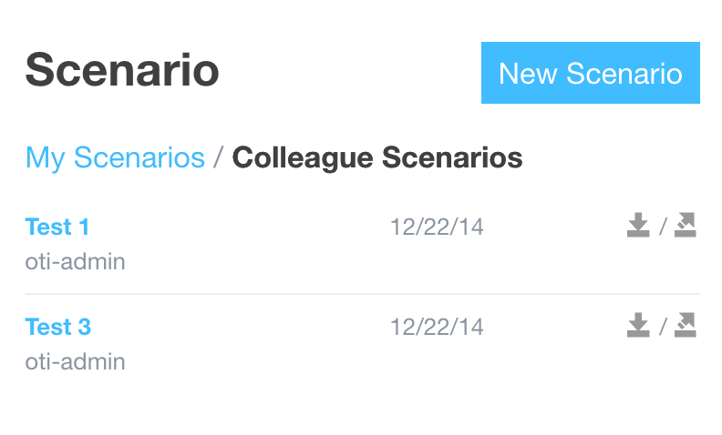

OTI supports multiple users. To copy a colleague’s scenario, click the copy button on the Scenario dialog.

# Acknowledgements

This user manual was developed to support the World Bank Open Transit Indicators project, with funding provided by AusAid.

The World Bank project team, led by **Ms. Holly Krambeck**, **Dr. Li QU**, and **Mr. Christopher DeSerio**, would like to express their sincere thanks to **Dr. Yulin JIANG**, Director of China Urban Sustainable Transport Research Center, for her unwavering support for the project and substantial inputs provided by her team, including **Dr. Cheng LI** and **Dr. Xianglong LIU**. The team would also like to thank **Mr. Lei YAN** from the Zhengzhou Bus Company for his diligent work in testing the platform and invaluable technical support he has provided to the other participating cities. And a special thanks to **Ms. Linghong ZOU**, the team intern during the summer of 2013, who helped build the critical foundations for the project.

The team would like to thank **Ms. Van Anh Thi Tran**, World Bank Senior Transportation Specialist and Task Team Leader for the Haiphong transport project, for her support for this initiative. The team would also like to express its appreciation for **Ms. Kate Chapman** and the Humanitarian OpenStreetMap Team, working with **Dr. Tran Khanh Toan** and **Professor Le Sy Xinh** from the Vietnam Maritime University’s GIS program, for their excellent work on open source digital mapping and GTFS data collection activities.

The team would also like to thank **Mr. Aaron Antrim**, founding principal of Trillium Solutions**; Mr. Michael Smith**, founding principal of Transitime; and **Ms. Bibiana McHugh**, IT Manager of Trimet – these three remarkable individuals provided critical guidance and technical knowledge to the participating pilot governments and to the team on GTFS and GTFS-RT.

The team would like to express its appreciation of **Mr. Kevin Webb**, founding principal of Conveyal, and **Mr. James Wong**, independent transport consultant, for inspiring the development of this project through their ground-breaking work in GTFS data analysis and open-source software development.

Finally, the team would like to thank **Mr. John Branigan**, Azavea GIS Project Manager, and his extensive team of talented and exceedingly hard working developers for truly going above and beyond the call of duty in building a software application to support better transit planning in developing countries.

Additional information on the project can be found from the following resources:

**Source Code Repository**

<https://github.com/WorldBank-Transport/open-transit-indicators>

**Transitime “stop\_times.txt” Generator**

***Tool for generating file required to evaluate transit system on-time performance in Open Transit Indicators***

<https://github.com/WorldBank-Transport/Transitime>

**International GTFS Training Materials: Link Repository**

<https://github.com/WorldBank-Transport/GTFS-Training-Materials/wiki/Link-repository-for-international-GTFS-training-materials>